מגישים: רתם קשאני ודויד קופלב

NLP תרגיל 2

# Training a feed forward neural network

Play 1:

vocab_size = 1000

epochs = 10

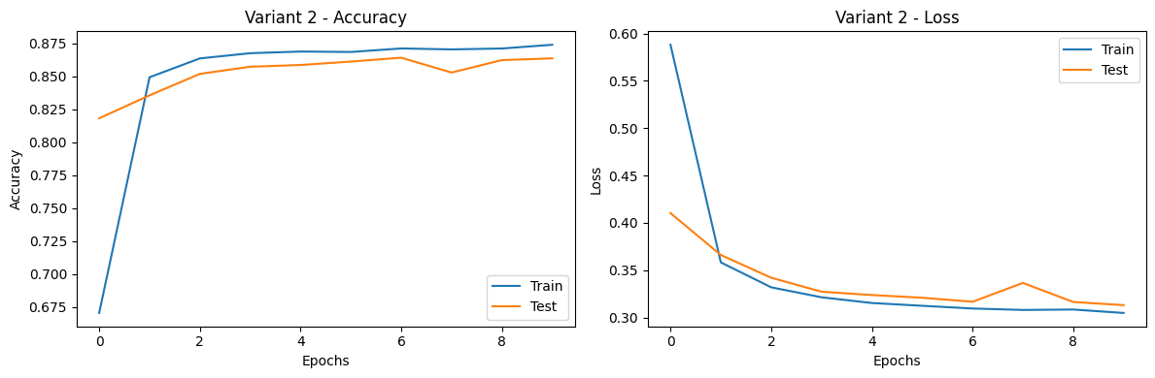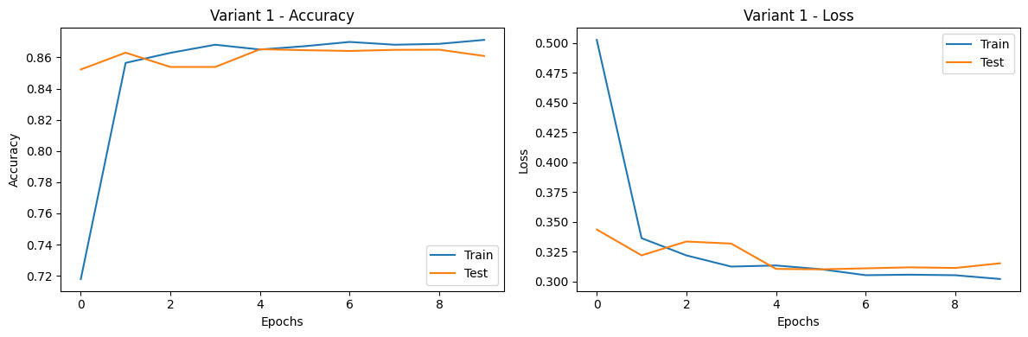batch_size = 32

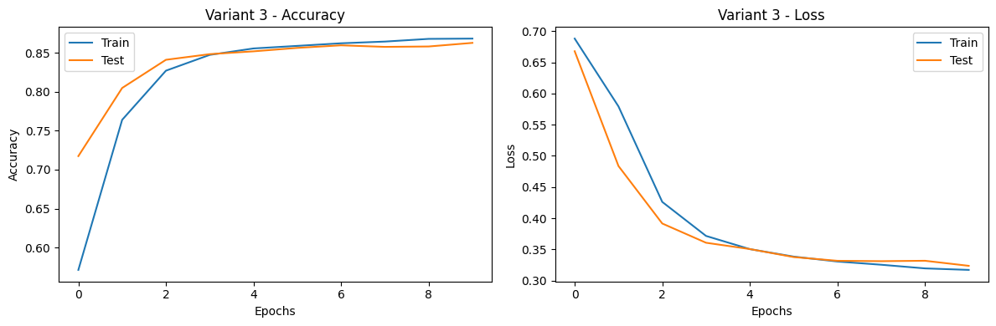

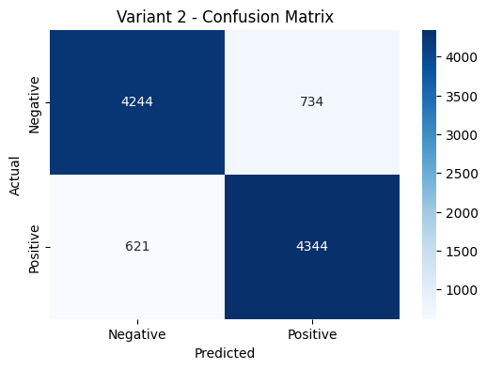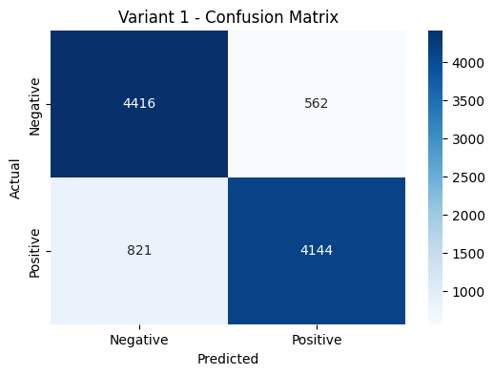

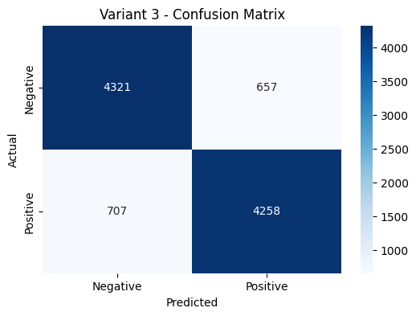

Play 2:

vocab_size = 2000

epochs = 10

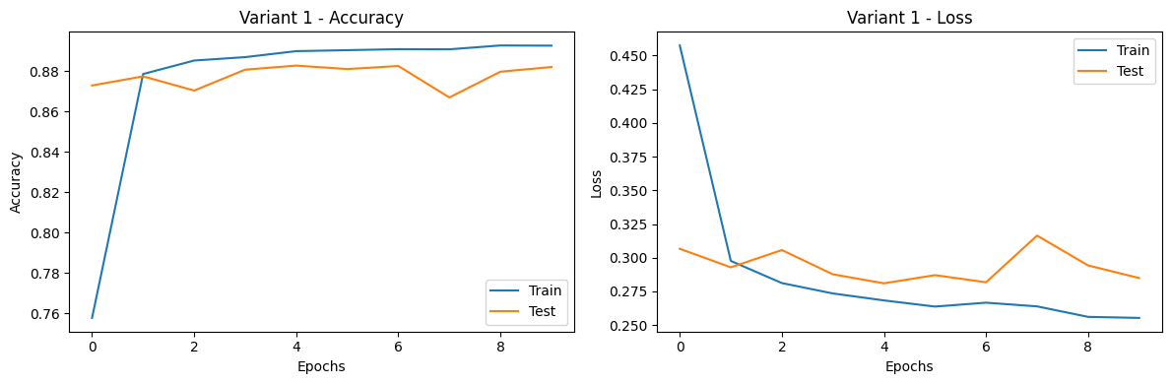batch_size = 32

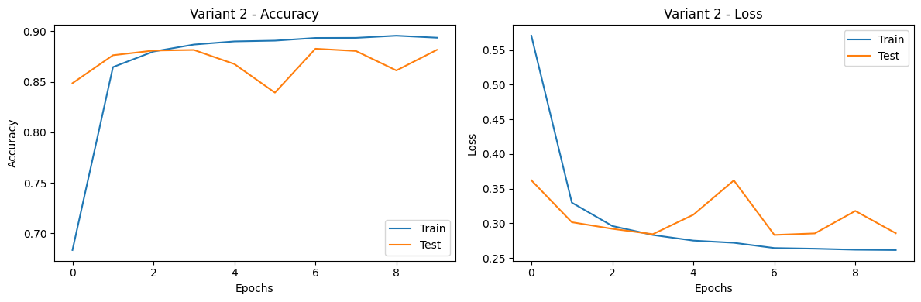

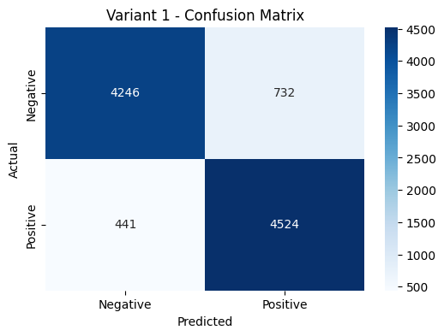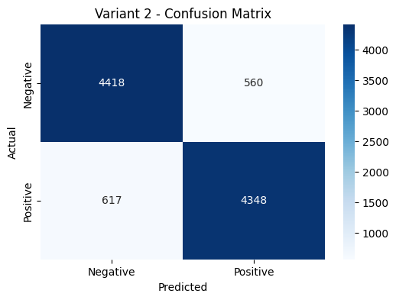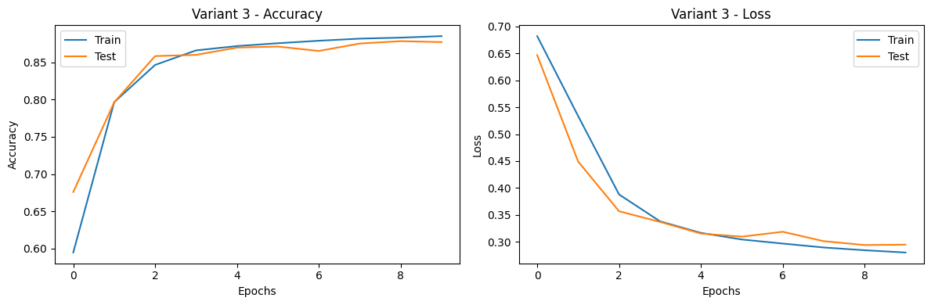

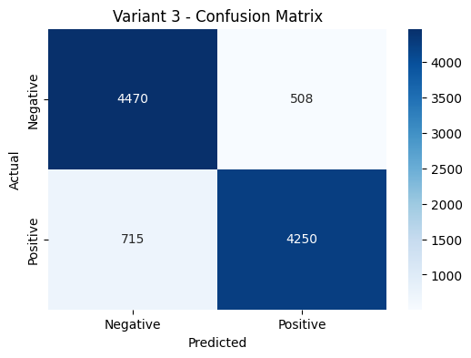

Play 3:

vocab_size = 3000

epochs = 10

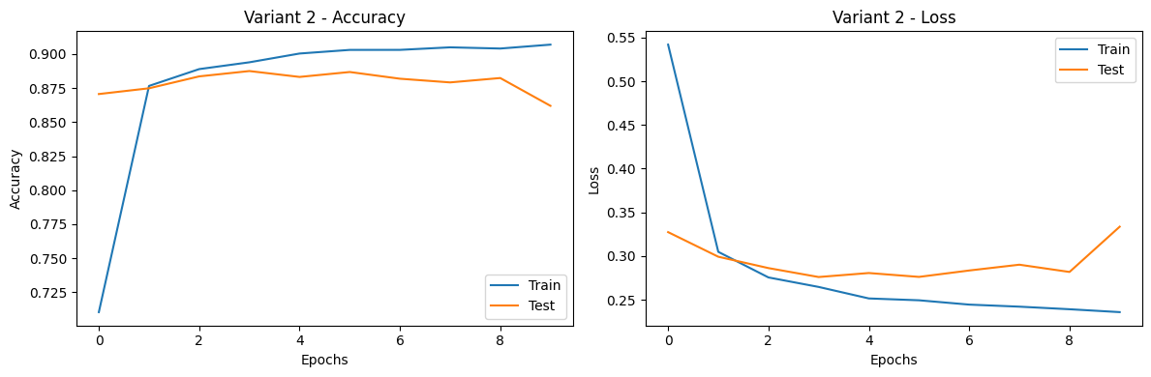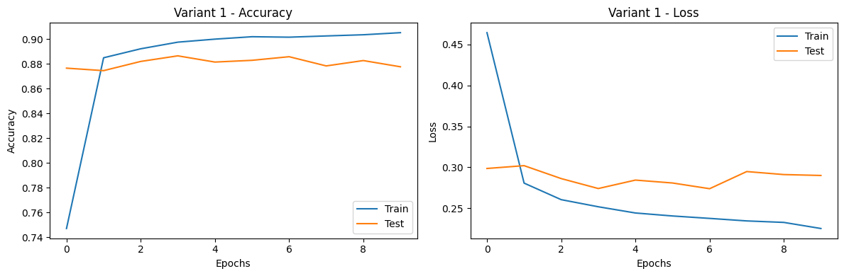batch_size = 32

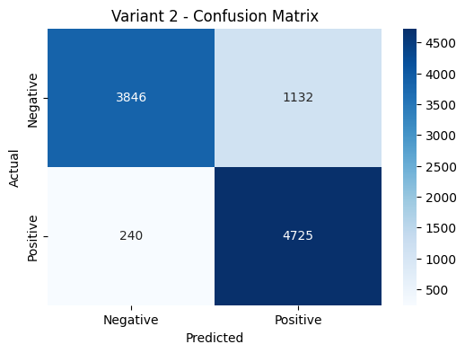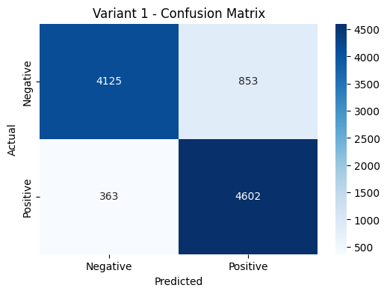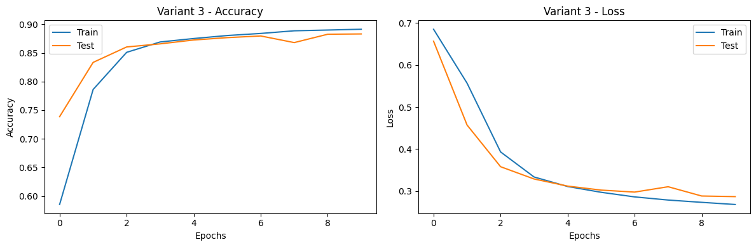

vocab_size = 3000 yields the best results among the options (1000, 2000, and 3000) for sentiment analysis because the loss is the smallest and the positive in the confusion matrix is the biggest.  
So we will continue playing (testing) with vocab_size = 3000.

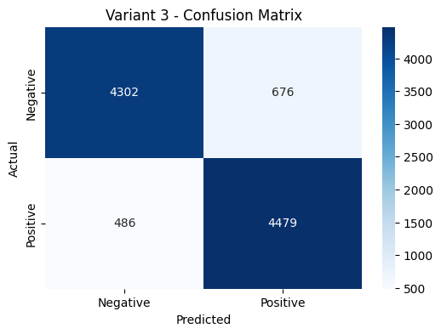

Play 4:

vocab_size = 3000

epochs = 20

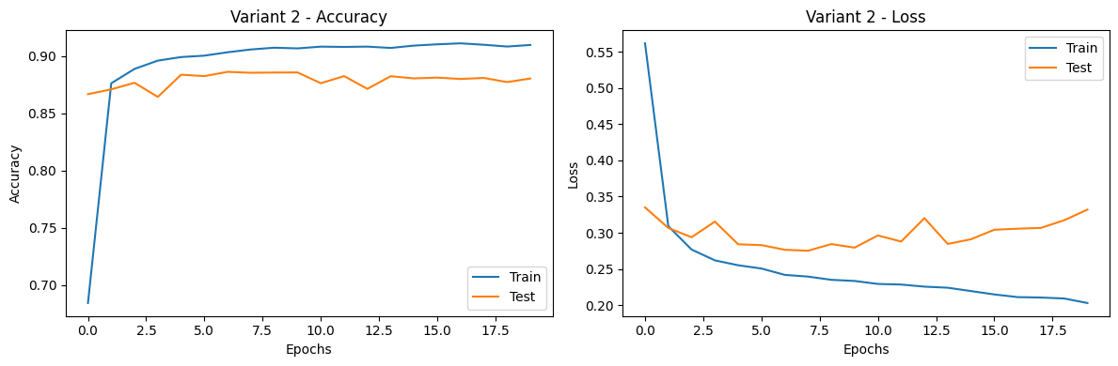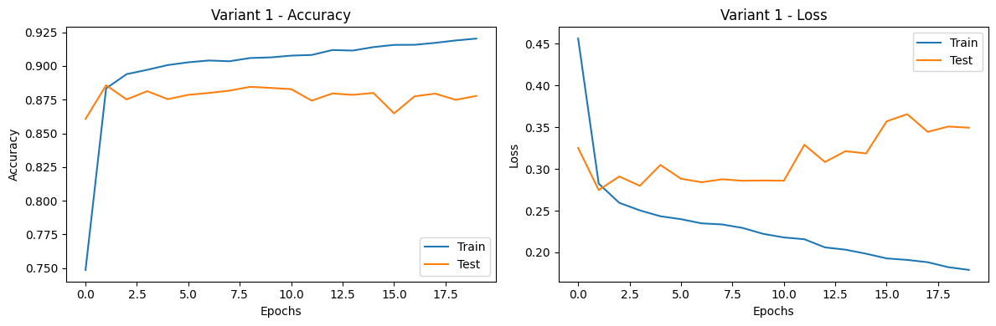batch_size = 32

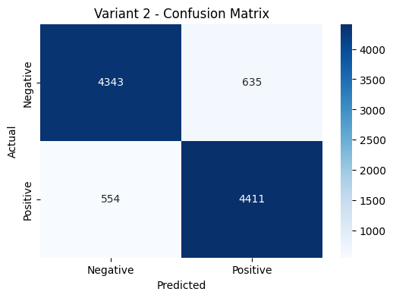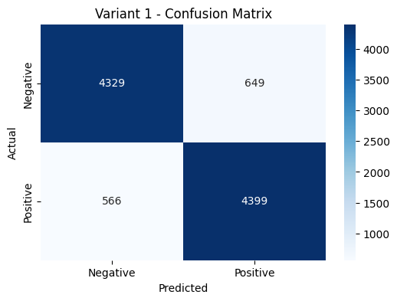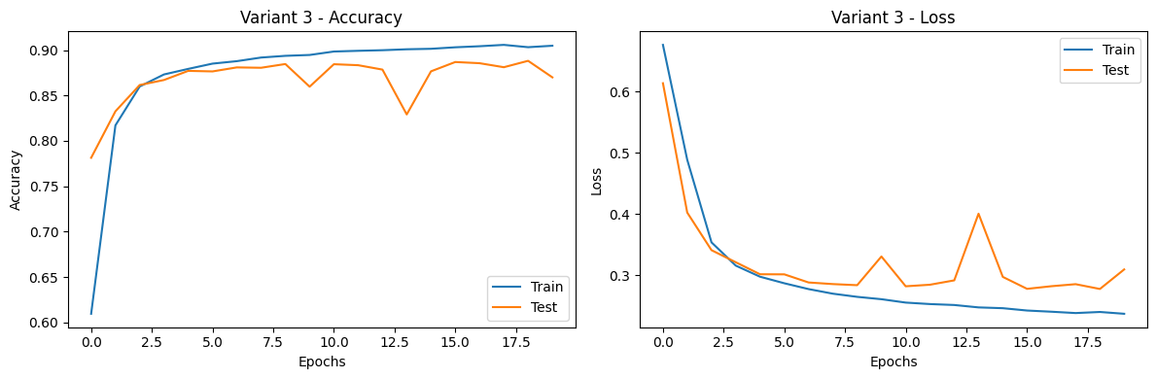

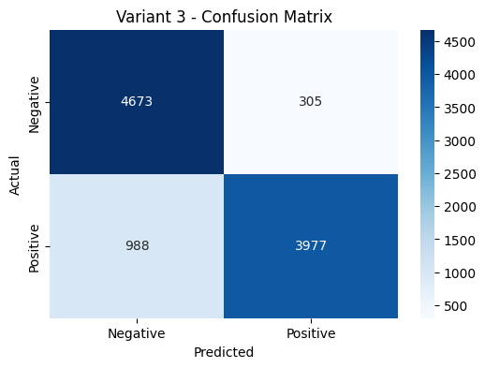

Play 5:

vocab_size = 3000

epochs = 30

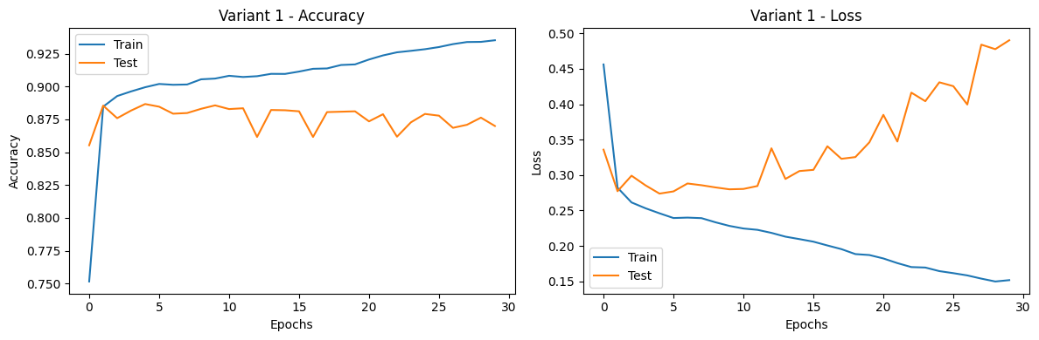batch_size = 32

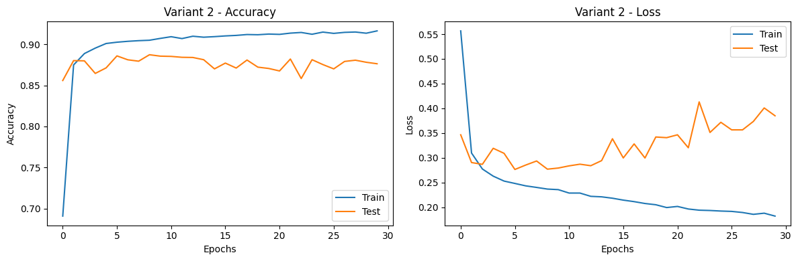

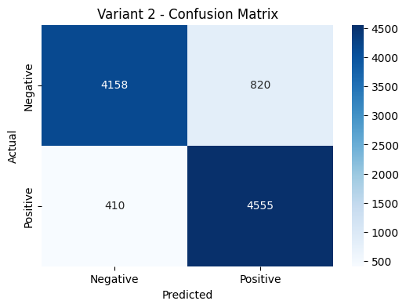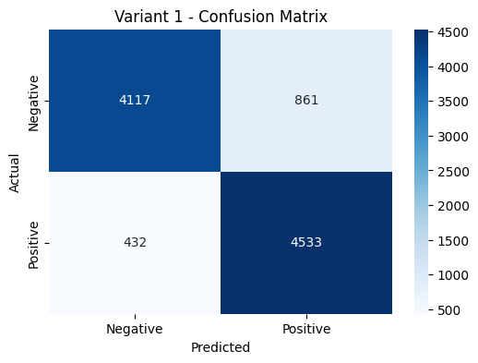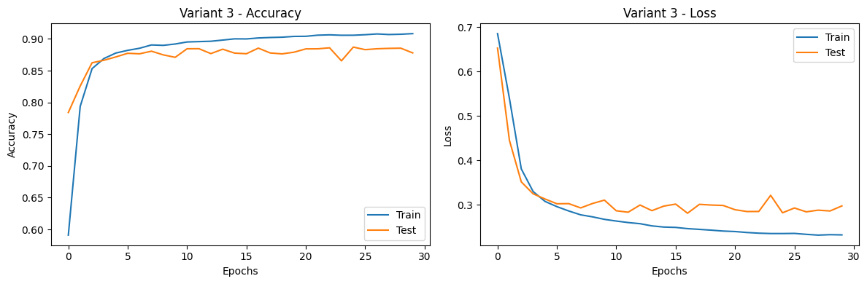

epochs = 20 yields the best results among the options (10, 20, and 30) for sentiment analysis because the loss is the smallest and the positive in the confusion matrix is the biggest so we will continue playing (testing) with epochs = 20

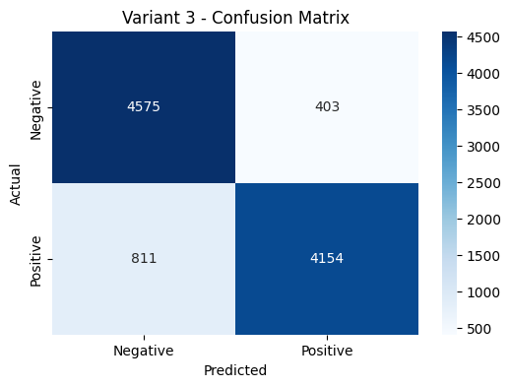

Play 6:

vocab_size = 3000

epochs = 20

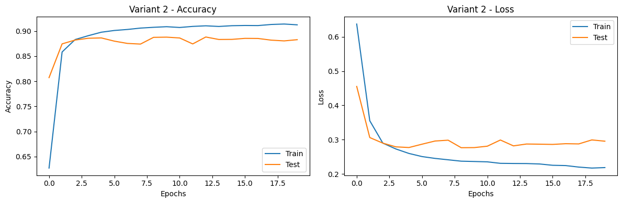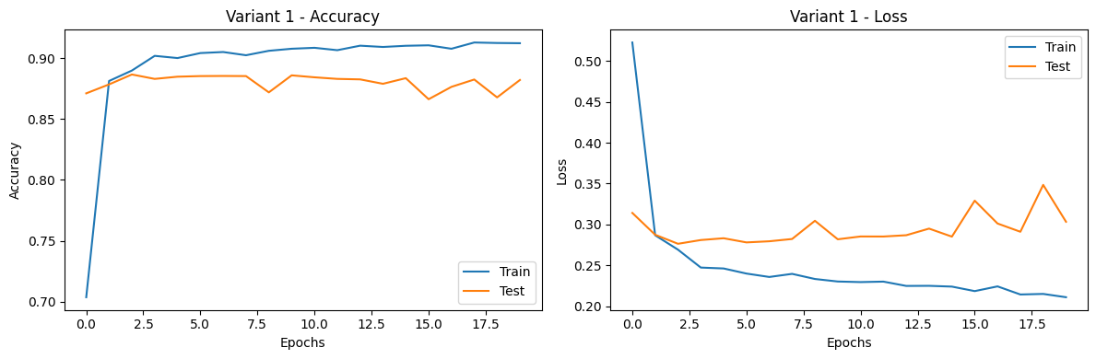batch_size = 64

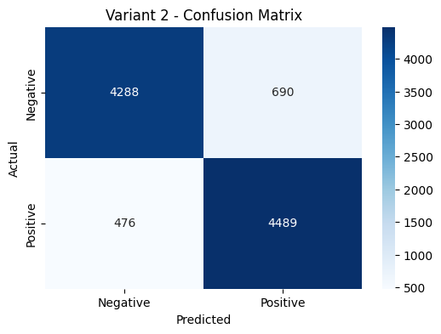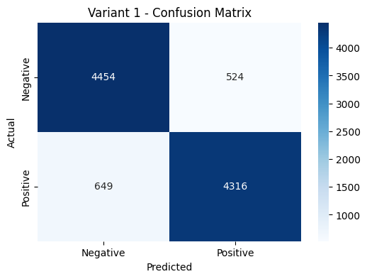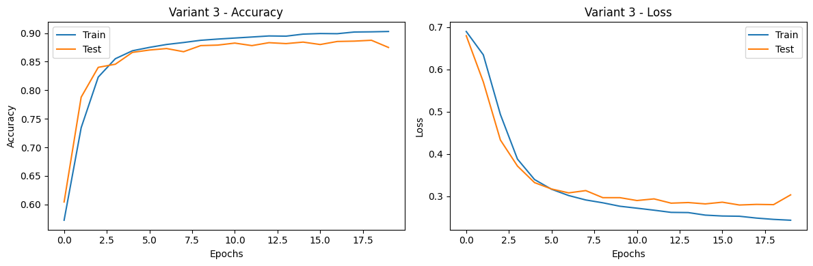

There is no significant difference between batch_size = 32 and batch_size = 64, so we chose batch_size = 25 in order to save running time

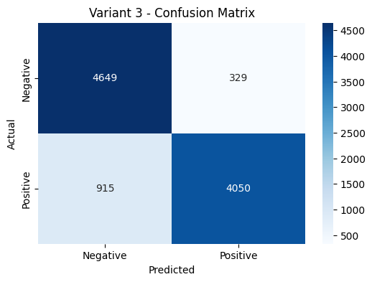

Play 7:

vocab_size = 3000

epochs = 20

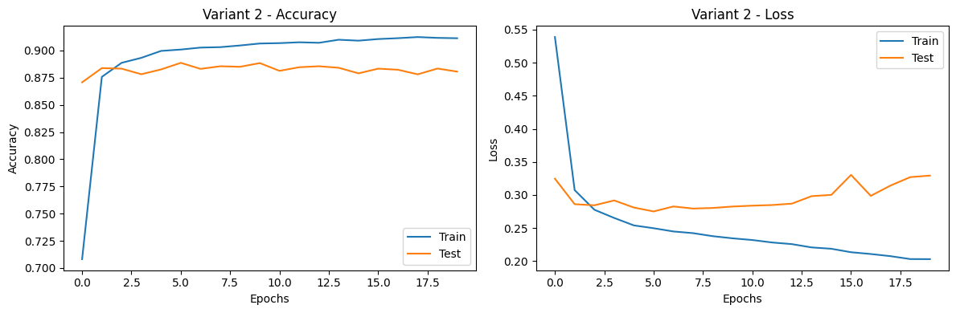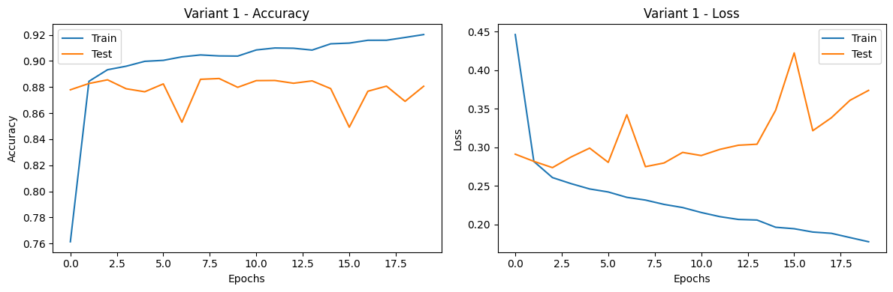batch_size = 25

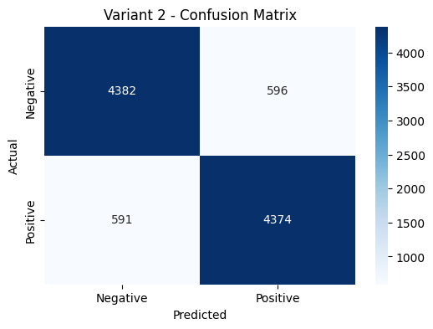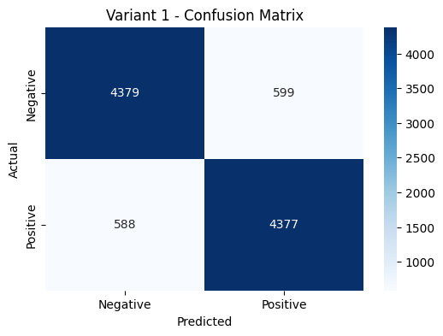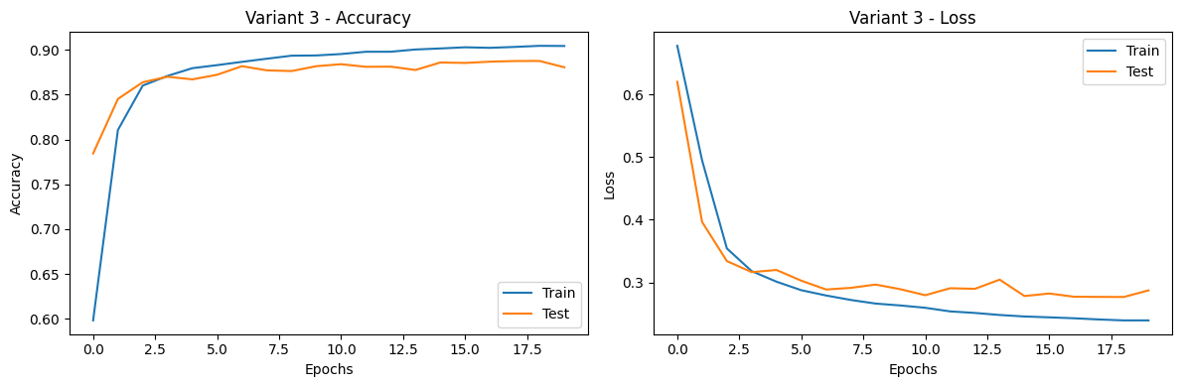

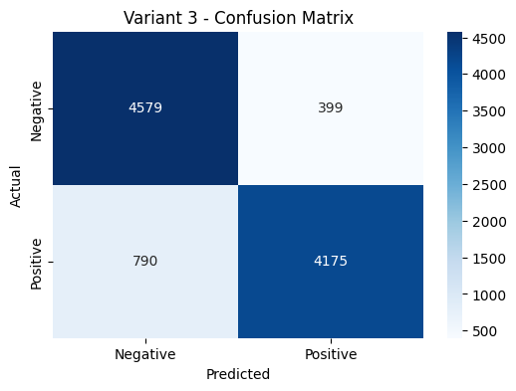

# Training a BiDir LSTM neural network

Play 1:

epochs = 10

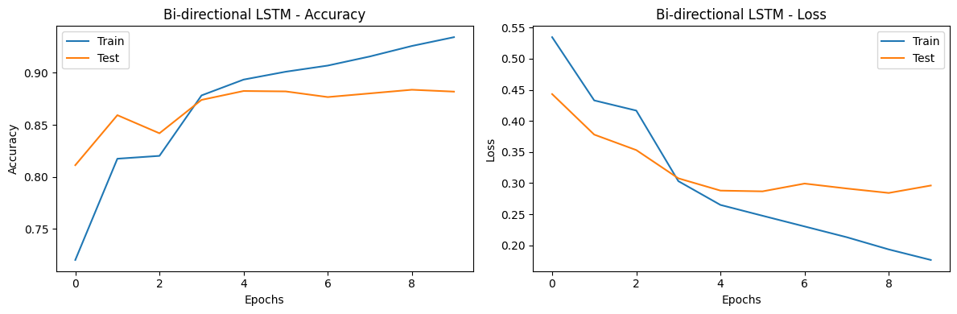batch_size = 32

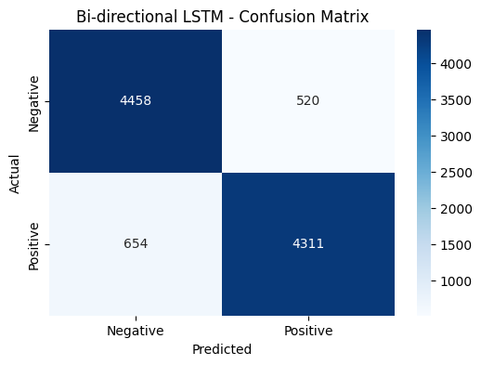Play 2:

epochs = 20

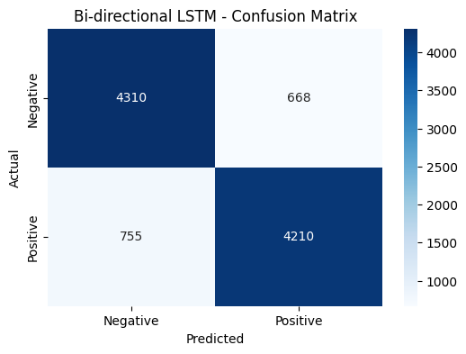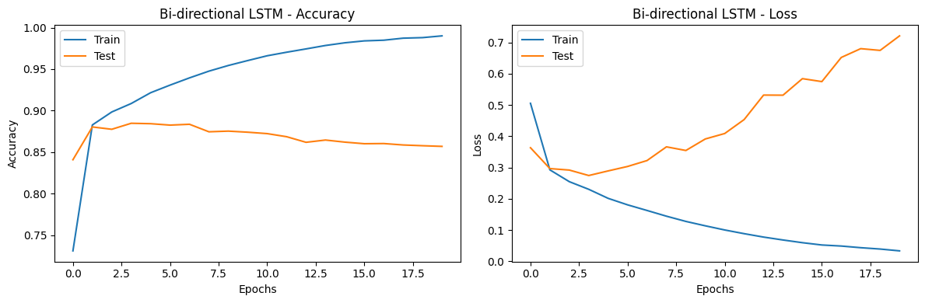batch_size = 32

Play 3:

epochs = 30

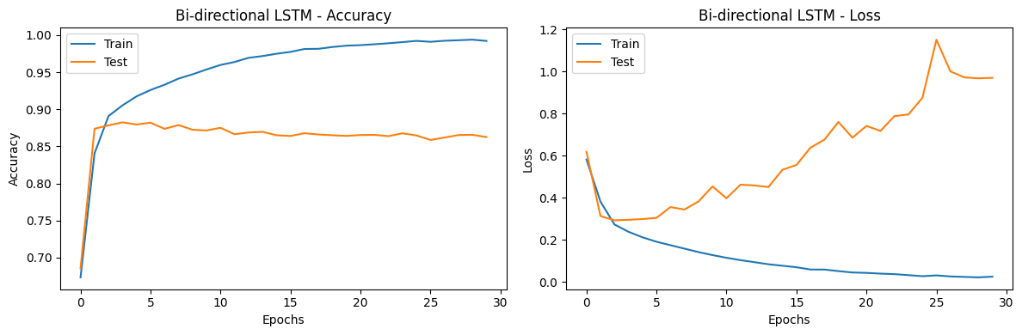batch_size = 32

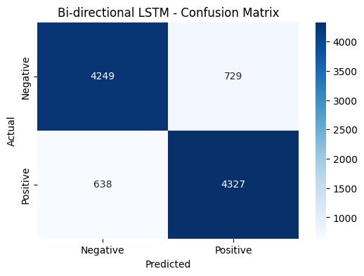

epochs = 10 yields the best results among the options (10, 20, and 30) for sentiment analysis because the loss is the smallest and the positive in the confusion matrix is the biggest so we will continue playing (testing) with epochs = 10

Play 4:

epochs = 10

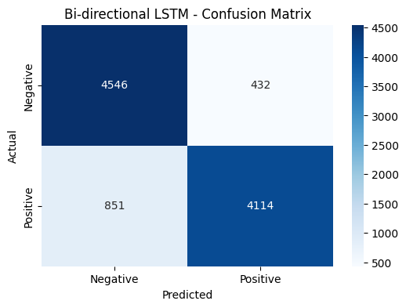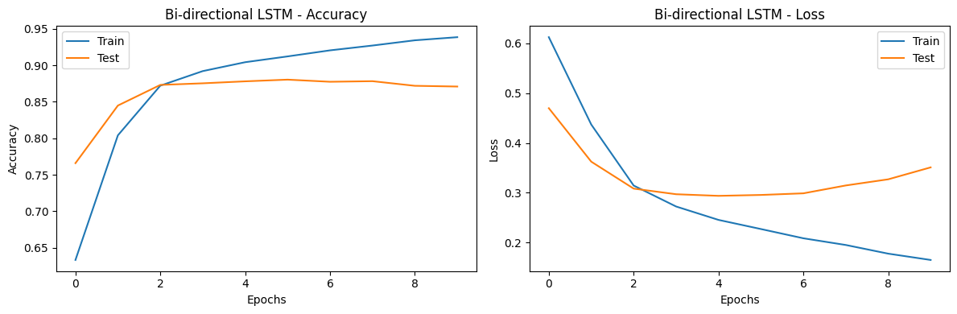batch_size = 64

When batch_size = 32 we got a lower loss and when batch_size = 64 we got a higher loss and therefore we chose batch_size = 25 in order to save even more on the loss and thus maximize the results

Play 5:

epochs = 10

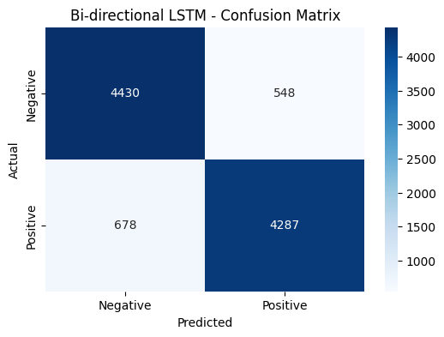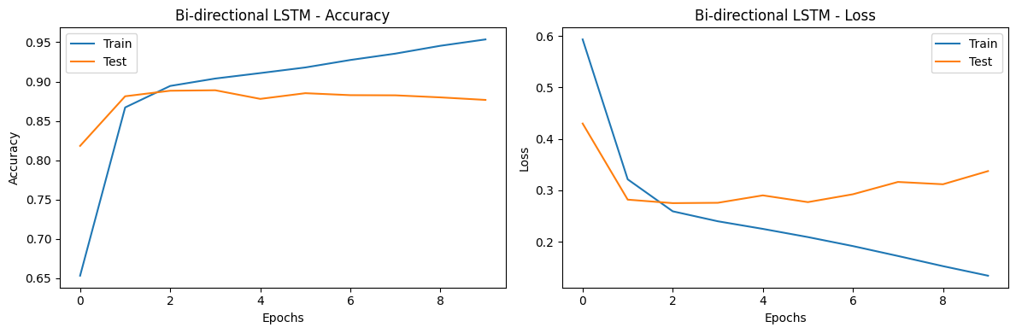batch_size = 25